# Segmentation analysis

## Current segmentation[1]

Segmentation for Utilization Rate

The funded balance and total commitment for utilization rate as of 5/31/2018 are shown below. Utilization is calculated by current balance divided by the total commitment.

|  |  |  |  |  |
| --- | --- | --- | --- | --- |
| Segment | Lines of Business | Funded Balance | Total Commitment | Utilization (%) |
| 1 | Floor Plan | 3,394,101,639 | 4,927,388,636 | 68.88 |
| 2 | CIB  (excl. ABL, ASG) | 8,871,402,349 | 42,941,261,543 | 20.66 |
| 3 | CML  (excl. Floor Plan, ABL, BBK Metro, BBK Regional) | 3,004,323,382 | 8,416,225,477 | 35.70 |
| 4 | PWM | 2,521,785,685 | 5,800,991,474 | 43.47 |
| 5 | ABL | 3,048,633,642 | 7,797,322,236 | 39.10 |
| 6 | RTL, BBK Metro, BBK Regional | 477,033,753 | 1,256,180,274 | 37.97 |
| 7 | CRE | 1,329,846,368 | 5,179,845,837 | 25.67 |
| Total | | 22,647,126,819 | 76,319,215,478 |  |

Figure 1: Current Segmentation for Utilization Rate as of 5/31/2018

Segmentation for Closure Rate

The closure rate is calculated from 5/31/2018 to 6/30/2018 on 5/31/2018 portfolio[2]. Closure rate is calculated by the closed commitment divided by all commitment, and this single monthly mortality (SMM) rate is annualized to have conditional prepayment rate (CPR).

|  |  |  |  |  |
| --- | --- | --- | --- | --- |
| Segment | Lines of Business | Closed Commitment | All Commitment | Closure (%) |
| Non-Retail | Seg 1, 2, 3, 4, 5, 7 | 2,123,853,704 | 75,063,035,203 | 29.14 |
| Retail | Seg 6 | 21,404,955 | 1,256,180,274 | 18.64 |
| Total | | 2,145,258,659 | 76,319,215,478 |  |

Figure 2: Current Segmentation for Closure Rate as of 5/31/2018

## Proposed Segmentation for Utilization Rate

The proposed segmentation is very similar to the current segmentation. The utilization rate is reported by line of business (LOB), so it is beneficial to keep the segmentation with respect to different line of business. The LOB of BBK Regional has been moved back to commercial (CML) in recent month, so model user proposed to move BBK Regional to Segmentation 3 to be included in the CML LOB[3]. The highlighted items have been updated from the proposed segmentation.

|  |  |  |  |  |
| --- | --- | --- | --- | --- |
| Segment | Lines of Business | Funded Balance | Total Commitment | Utilization (%) |
| 1 | Floor Plan | 3,394,101,639 | 4,927,388,636 | 68.88 |
| 2 | CIB  (excl. ABL, ASG) | 8,871,402,349 | 42,941,261,543 | 20.66 |
| 3 | CML  (excl. Floor Plan, ABL) | 3,104,137,277 | 8,755,438,903 | 35.45 |
| 4 | PWM | 2,521,785,685 | 5,800,991,474 | 43.47 |
| 5 | ABL | 3,048,633,642 | 7,797,322,236 | 39.10 |
| 6 | RTL | 377,219,859 | 916,966,849 | 41.14 |
| 7 | CRE | 1,329,846,368 | 5,179,845,837 | 25.67 |
| Total | | 22,647,126,819 | 76,319,215,478 |  |

Figure 3: Proposed Segmentation for Utilization Rate as of 5/31/2018

### Justification on Proposed Segmentation for Utilization Rate

Exclusion of ASG from CIB (Segment 2)

Assert Securitization Group (ASG) is managed by the model users to have a target utilization rate, so it is not currently included in the utilization model. The historical ASG commitment (i.e., face_amt in the figure below) is around 6 billion.

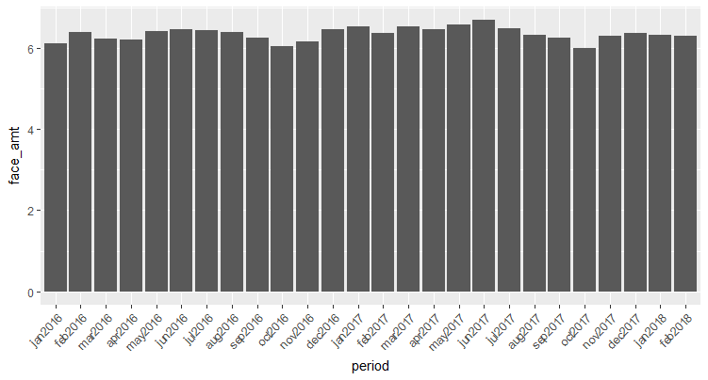

Figure 4: Historical Commitment of ASG

Model users suggested reviewing the historical utilization rate of ASG vs. CIB without ASG using the recent period (from January 2016 to February 2018)

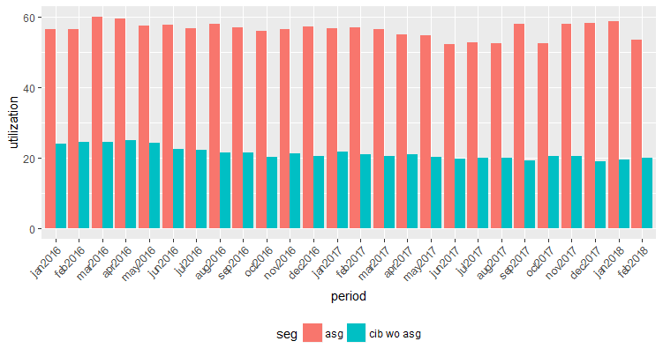

Figure 5: Utilization Rate comparison between ASG and CIB w/o ASG

It is observed that the ASG utilization (around 55%) is much larger than the CIB without ASG (around 20%) to justify that the asset should be excluded from the segmentation 2[4].

Inclusion of BBK Metro and BBK Regional to CML (Segment 3)

Business users suggested moving back BBK Metro and Regional back to commercial (CML) LOB to reflect the recent change in LOB.

The plot below compares utilization rate of CML and utilization rate of BBK Metro and Regional. The detailed filtering logic for BBK Metro and Regional is explained in the email[5], as the sub-lob field names have been changed in past 2 years.

Model developer observed that the difference between CML utilization and BBK utilization is within +/- 5% to justify the inclusion of BBK Metro and Regional to Segmentation 3 (CML).

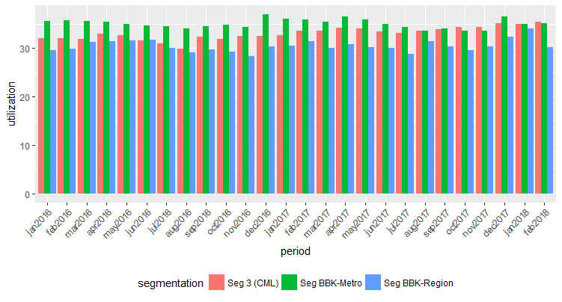

Figure 6: Utilization Comparison between Segment 3 and BBK Metro / Regional

## Proposed Segmentation for Closure Rate

Utilization rate is reported with respect to business LOBs, but closure rate is reported with respect to product types. As such, model users suggested examining the closure rates for following product types[6] [7]:

* CRE ($0.57B),
  + CRE Construction [$0.09B],
  + CRE Investor Owned [$0.26B],
  + CRE Owner Occupied [$0.22B],
* Commercial Tax Exempt [$0.23B],
* Commercial Floor Plan [$3.4B],
* Commercial Domestic [$18.3B],
  + Commercial Loan Domestic Planning [$15.3B],
  + Asset Based Lending (ABL) [$3B],
* Commercial International [$0.8B]

Model developer provided the historical closure rates segmented by product types (from Feb 2016 to Feb 2018) in the figure below.



Figure 7: Closure Rate Segmentation by Product Type

The first group (‘nrtl’) is the Non-Retail which consists of all product types (i.e., cre, domestic, floor plan, international and tax exempt for non-retail). As the domestic has the biggest balance, closure rate of domestic represents the whole non-retail group. Model developer observed that closure rate for CRE, floor plan, international and tax exempt were unstable across periods. The last group (‘rtl’) is the Retail which consists of consumer LOB and BBK Metro.

Model developer and model users agreed to have following segmentation for closure rate[8]:

|  |  |  |  |
| --- | --- | --- | --- |
| Product Type | Closed Commitment | All Commitment | Closure (%) |
| Domestic (Non-Retail) | 1,770,835,747 | 66,620,450,975 | 27.62 |
| Retail | 12,397,479 | 916,966,849 | 15.07 |

Figure 8: Proposed Closure Rate Segmentation as of 5/31/2018

It should be noted that the product type filtering requires new aggregation logics which are different from the aggregation logic used for the current closure rate in Figure 2[9]. Also, CRE, floor plan, international and tax exempt have been proposed to be excluded from the closure rate model for non-retail. Model developer justified segmentation logics based on number of closed accounts and balance size per month. Detailed justification is provided in the following sections.

### Justification on Proposed Segmentation for Closure Rate

Segmentation by Product Type

It is natural to ask the reason why the closure rate model did not follow the same segmentation (i.e., segment with respect to LOBs) as in utilization rate model. The figure below shows the historical closure rate by the 7 segmentations listed in Figure 1.



Figure 9: Closure Rate by LOB (i.e., Segmentation used in Utilization Rate)

It is not easy to find the stable trend of closure rate across sampling periods. Model users assumed that closure behavior would be more homogenous with respect to the product type not by the LOB. For instance, product type of ‘domestic’ is generated by following non-retail LOBs as of May 2018 portfolio[10]:

* CIB LOB: $40.7B
* CML LOB: $7.7B
* Private Wealth Management (PWM) LOB: $5.3B
* CRE LOB: $4.6B

Also, the segmentation by product type is beneficial for the business, as model users generate closure rate report with respect to different product type.

Exclusion of Floor Plan

The balance of floor plan is around $3.4B as of May 2018 portfolio, so it needs to be included in the closure model. However, model developer observed from the closure rate of floor plan in Figure 7 that the floor plan showed very unstable closure rate across the sampling periods.

Model developer examined the particular period in Dec 2016 to Feb 2017, when the floor plan closure rate was changed to 0%, 28.43%, 3.2%, respectively.



Figure 10: Floor Plan Closed Account as of Dec 2016, Jan 2017 and Feb 2017

The 0% closure rate in Dec 2016 indicates that there was no closed account. There were 6 accounts closed in Jan 2017 to jump the closure rate to 28.43%. The following month (i.e., Feb 2017), there were only 3 accounts closed to have 3.2% closure rate.

Model developer observed that less than 10 accounts were closed each month, and the total commitment on these account is subject to the idiosyncratic characteristic of loans. Therefore, model developers do not expect to have stable closure rates, when month-to-month number of closed account is small.

Model developer and users agreed to exclude floor plan from the closure rate model. Floor plan closure rate would be managed by subject matter expert (SME) based on the current view on the market condition.

Exclusion of International

Commercial International has $0.8B balance as of May 2018 portfolio to be the second largest product type which is proposed to be excluded from the closure rate modeling.

Model developer also observed that the unstable closure rate is caused by the small number of closed account in each month. The example of unstable closure rate of international product type from Oct 2017 to Dec 2017 is shown below.



Figure 11: International Closed Account as of Oct 2017, Nov 2017 and Dec 2017

It is observed from the example that there are very few closed accounts (less than 5 accounts) for international product type. As such, the closure rate is expected to be subject to the idiosyncratic characteristic of loans.

Model developer and users agreed to exclude international from the closure rate model. The closure rate for this product would be managed by SME based on the current view on the market condition.

Exclusion of Tax Exempt and CRE

Tax exempt and CRE product types also suffered from the small number of closed account. Also, the balance as of May 2018 was $0.23B and $0.57B, respectively. Model developer concluded that the closure rate of tax exempt can be managed SME based on the current market condition.

## Appendix

### R Code





### Excel Spreadsheet for Result Summary





### Email Communication





1. Titova, S., Venkatesan, S., Wholesale Line of Credit Utilization-Closure Model, Model Documentation, 7/14/2017
2. Unlike utilization rate, closure rate is calculated by looking at the commitment of portfolio in two consecutive months. If account has been removed in next month or commitment becomes zero, we are assuming the account has been closed.
3. It should be noted that BBK Metro remains in Segment 6 (Retail).
4. Email from Svetlana Titova, RE:SAG commitment and utilization rate for Segmentation 2, 5/1/2018
5. Email from Bill Sung, Utilization comparison among CML, BBK-Metro and BBK-Region, 6/14/2018
6. Email from Shirley Xue, RE: Utilization Model Refresh – Data Request, 7/3/2018
7. Values in the square bracket are the current balance as of May 2018.
8. Model developer and users agreed to keep the non-retail / retail segmentation for closure rate model. However, we wanted to have more granular closure rates for different product types in non-retail.
9. Current closure rate is aggregated by account id and utilization segmentation. Utilization segmentation is more granular than closure segmentation (non-retail vs. retail), so aggregation by utilization segmentation was sufficient. However, the proposed closure segmentation by product type is more granular than segmentation used in utilization. For instance, utilization segment 2 (CIB) would have domestic, international, CRE product types. As such, we needed to aggregate by account id, utilization segmentation and product type.
10. The value next to each LOB is the total commitment.